ABSTRACT TITLE

Presenting Author Underlined,¹* Autor Name,² …
¹Department, Institution, Address, City, Country (please go from detail to general)
² Department, Institution, Address, City, Country (please go from detail to general)
*presenting author e-mail

Abstracts should be 1 full page long (any abstracts longer or shorter will not be taken into consideration). The manuscript should be saved with the presenting author’; name as “FirstName LastName” and submitted as a .doc or .docx file in the dedicated section of PolyChar’30.
Page layout details: margins: upper 2.5 cm, lower 2.5 cm, left 3 cm, right 2.5 cm; orientation: portrait; size: A4 (21 × 29.7 cm); one column.
Font details: title: Calibri Light, 12 point, full uppercase, boldface; authors: Calibri Light, 11 point, boldface, affiliation: Calibri Light, 11 point, italic; all other text: Calibri Light, 11 point, regular.
Paragraph details (alignment, indentation and spacing): title, author list, affiliations, figure, figure caption: centered, no indentation, no before/after spacing, 1.15 lines (multiple) line spacing; all other text: fully justified, no indentation, no before/after spacing,1.15 lines (multiple) line spacing.
Figure and figure caption should be placed in the main text near to the first time they are cited.

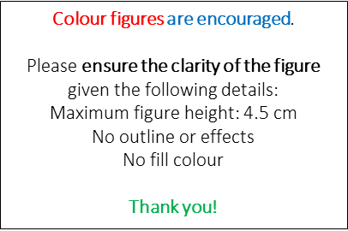
Figure X. Description of the figure. For multiple panels: Description of what is contained in the first panel (a) and description of what is contained in the second panel (b).

References should be numbered in the order of their appearance and indicated by a numeral or numerals in square brackets after the first punctuation mark. [1,2] Please provide a list of up to five references (present both in the main text and in the reference list), using the style detailed below.

Acknowledgements: Thank you for your contribution to PolyChar’30.

References:
- For journal articles: A. Author, B. Author, C. Author, Title of the article, Journal Abbreviation (please use the CASSI abreviation) volume, inclusive pagination (or article number), year.
- For books: A. Author, B. Author, C. Author, Book title, edition number (if any), Series information (if any), Publisher: Place of publication, volume number, inclusive pagination, year.
- For book chapters: A. Author, B. Author, C. Author, Book chapter title. In Book title, ed.: A. Editor, B. Editor, Publisher: Place of publication, inclusive pagination, year.
- For online resources: A. Author, Document title, year, http://www.source.com, Accessed DD Month YYYY.

